Embedded Computer Architecture

Assignment 2 – Optimisation of Mining Application using GPU

Sindhuja Chandrasekaran- 0926903

Esakki Raja - 0927494

Contents

**Introduction** 2

**Application to be Optimized** 2

**CUDA Framework** 2

**Porting of Application in CUDA** 3

**Optimization of Application** 4

**Conclusion** 8

# **Introduction**

The purpose of this assignment is to optimize the performance of the given Mining application. This is achieved by utilising the Graphical Processing Unit(GPU) to perform computations that are initially being handled by the CPU. Though the GPU is typically used for image processing, in this case it is used for General Purpose computations, since it offers high level of parallelism and thus improving the efficiency of the program.

The mining application in this assignment is to earn coinporaal coins by solving the hashes. This report explains about mining application & how it is being optimised using CUDA and the analysis of the obtained results.

In section 1, we have discussed about the mining application and its function. The source code of the mining application was provided in C version. Section 2 describes the CUDA framework which helps to port the given C code to CUDA C. This porting helps the host(CPU) to interact with the device(GPU). The porting of the given source code to CUDA has been explained in Section 4.

In the final two sections, we have provided the optimization techniques such as Reduce kernel management overhead, Reduce Memory management overhead, Reduce memory transfer overhead and other bottlenecks that are implemented and the results achieved in the benchmark of the server.

# **Application to be Optimized**

The application requests for a block from the competition server which consists of base string and a multiplier. A nonce string (‘a’…’z’,’A’...’Z’,’0’…’9’) is then appended to the input block. The hash function then produces an output of 64 characters for this input block. It is considered to have found a valid coin if this output starts with ’0000’. Hence for one input block, 62 nonces are possible and thus the hash function is being performed 62 times for one input block from the server.

When the hash function is being implemented on GPU, the GPU can implement this function for 62 different nonces simultaneously. This is expected to increase the performance of the application.

# **CUDA Framework**

CUDA is a parallel programming model that can be implemented on GPU. Since it is created by NVIDIA, such programs can only be implemented on CUDA enabled GPU devices.

CUDA has two important components: Kernels and Threads. In CUDA, the parallel portions of an applications are executed on the device as kernels and one kernel is executed at a time. In kernel, the basic unit of execution is thread & they are organized blocks. These blocks are organized in grids. The values of threads, blocks and grids are passed at the launch of the Kernel.

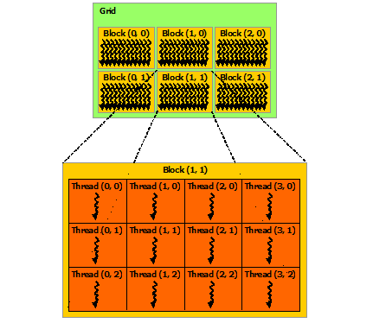

In order to port the provided application into CUDA C , the device memory allocation and the data transfer from host to device has to be taken care of. This is done by calling Cudamalloc() and cudaMemcpy() functions.

# **Porting of Application in CUDA**

The porting has been done for the part of the code that appears as a bottleneck with higher computational complexity. We observed that the hash function is the major computational bottleneck and thus it has been ported to CUDA to implement it in GPU. The hash function is launched as a Hash kernel by the host code. On further analysing, since there are scope for parallelism in stringToHex function, it is also included as a device function and is called by the Hash kernel. Also, the function called by hash function are made as device functions. The rest of the functions(benchmark(), requestInput, ValidateHash) are implemented by the host code. The Hash kernel is being implemented in such a way that the output of the Hash kernel is nothing but the nonce of a found valid coin. The kernel is initially launched with 62 blocks and 1 thread and the number of threads was later increased to 32.

In the following tabulation, we see the code snippets of C-version and ported code of the hash kernel call. The memory is allocated for the input and output in the global memory space which is accessed by both.(CPU & GPU). The input is then copied from host to device before making the kernel call and the output is copied from device to host after the execution of the kernel.

|  |  |
| --- | --- |
| C - Version | CUDA C |
| //do hash  Hash(input, output_hash); | char* dev_inputmain;  char* dev_outputmain;  char outputmain[2]={'\0', '\0'};  cudaStatus = cudaMalloc((void**)&dev_inputmain, inputSize * sizeof(char));  .  .  .  .  cudaStatus = cudaMemcpy(dev_inputmain, input, inputSize * sizeof(char), cudaMemcpyHostToDevice);  …..  HashKernel << < 62, 32 >>  …..  cudaStatus = cudaMemcpy(output, dev_output, 2 * sizeof(char), cudaMemcpyDeviceToHost); |

|  |  |
| --- | --- |
| C- Version | CUDA C |
| while(p+sizeof(uint32_t)*BW <=inputSize) {  for(unsigned int q=0; q<BW; q++) {  in[q] = 0;  for(unsigned int w=0; w<sizeof(uint32_t); w++)  in[q] |= (uint32_t)((unsigned char)(input[p+q*sizeof(uint32_t)+w])) << (8*w);  }  p += sizeof(uint32_t)*BW;  InputFunction(in);  RoundFunction();  } | while (p + sizeof(uint32_t)*BW <= inputSize) {  __syncthreads();  if (thd < 32){  tempIn[thd] = input[thd + p]; }  __syncthreads();  if (thd < 8)  { in[thd] = 0;  unsigned int temp = thd * sizeof(uint32_t);  for (unsigned int w = 0; w < sizeof(uint32_t); w++){  unsigned int inputIndex = temp + w;  if (inputIndex == 0 && p ==0){  in[thd] |= (uint32_t)((unsigned char)(hashnonce[0])) << (8 * w); }  else{  int test = (uint32_t)((unsigned char)(tempIn[inputIndex])) << (8 * w);  in[thd] |= (uint32_t)((unsigned char)(tempIn[inputIndex])) << (8 * w);  } |

# **Optimization of Application**

The code was run initially in the host (CPU) and we checked the output of the benchmark in the server. The output of the benchmark result is shown below. The expectation now is that the ported code should reduce the time taken to find the valid coins for the same number of inputs(5000).

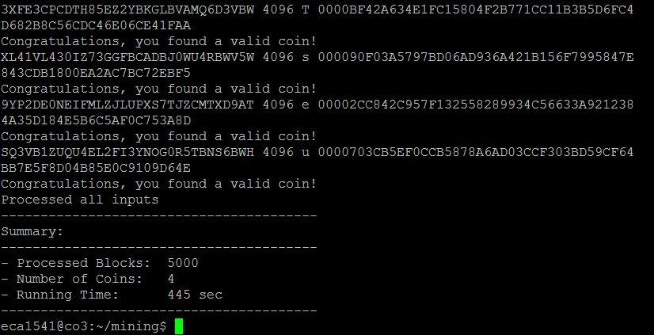

Figure: Benchmark Results

**Implementation with 62 blocks and 1 thread**

After porting the code to CUDA C, the code was run in the visual studio, “NSIGHT- Visual Profiler” that provides statistical analysis of the functions and threading involved in the CUDA C. Initially, we have ported our code with **62 blocks and 1** **thread** and analysed the result to optimize further.

Kernel call is deployed with 62 blocks with each block processing one particular nonce for the given base and multiplier. Since all of them get processed in parallel, the running time is reduced considerably. The output of the NSIGHT visual profiler and bench mark is shown below.

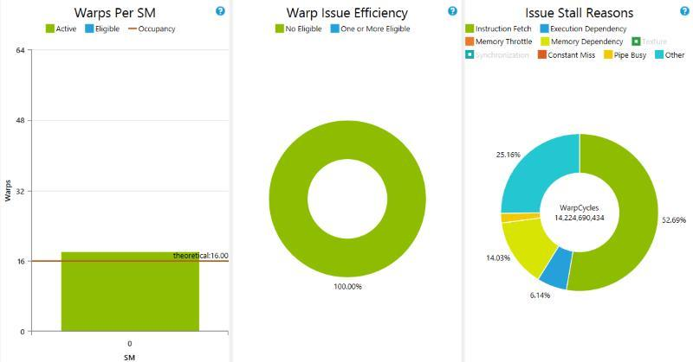

Figure : NSIGHT Visual profiler- 62 Blocks & 1 Thread

**Implementation with 62 blocks and 32 thread**

By analysing the profiler data of the previous implementation, we took following optimization techniques into motivation and we have ported the code with 62 blocks and 32 threads. This avoids the usage of synchronization threads that reduces the consumption of the GPU cycle. The following methods are the optimization techniques and bottlenecks that are implemented.

1. **Reducing Memory Management Overhead:** The CUDA memory management functions cudaMalloc and cudaFree are more than two orders of magnitude more expensive than the equivalent C standard library functions malloc and free. Hence, by allocating memory once at the beginning of an application and, that memory is reused in each kernel invocation.
2. Accessing shared memory is much faster than global memory. Therefore the input to the hash kernel is first copied as 32 blocks to shared memory, i.e according to the below code snippet each iteration requires 32 characters from the input block to perform computation. Hence instead of accessing input[] (which resides in global memory)for every computation, the required 32 characters are first copied to the shared memory i.e., tempIn[], for which the access rate is much faster.

*while (p + sizeof(uint32_t)*BW <= inputSize) {*

*__syncthreads();*

*if (thd < 32){*

*tempIn[thd] = input[thd + p]; }*

*__syncthreads();*

*if (thd < 8)*

*{ in[thd] = 0;*

*unsigned int temp = thd * sizeof(uint32_t);*

*for (unsigned int w = 0; w < sizeof(uint32_t); w++){*

*unsigned int inputIndex = temp + w;*

*if (inputIndex == 0 && p ==0){*

*in[thd] |= (uint32_t)((unsigned char)(hashnonce[0])) << (8 * w); }*

*else{*

*int test = (uint32_t)((unsigned char)(tempIn[inputIndex])) << (8 * w);*

*in[thd] |= (uint32_t)((unsigned char)(tempIn[inputIndex])) << (8 * w);*

*}*

1. The device function ‘RoundFunction' is implemented 32 threads. The rounding of the b array is implemented using threads thus increasing parallelism.

*__device__ void RoundFunction(uint32_t r_thrd)*

*{*

*__shared__ uint32_t q[BW];*

*if(r_thrd < 8)*

*{*

*q[r_thrd] = b[248+r_thrd];*

*}*

*__syncthreads();*

*if(r_thrd<31)*

*{*

*unsigned int bIndex1= 248-(r_thrd*8);*

*unsigned int bIndex2= bIndex1-8;*

*for(unsigned int j=0; j<BW; j++)*

*b[bIndex1+j] = b[bIndex2+j];*

*}*

*if(r_thrd==31)*

*{*

*for(unsigned int j=0; j<BW; j++)*

*b[j] = q[j];*

*}*

*__syncthreads()*;

The output of this implementation in the benchmark is shown below.

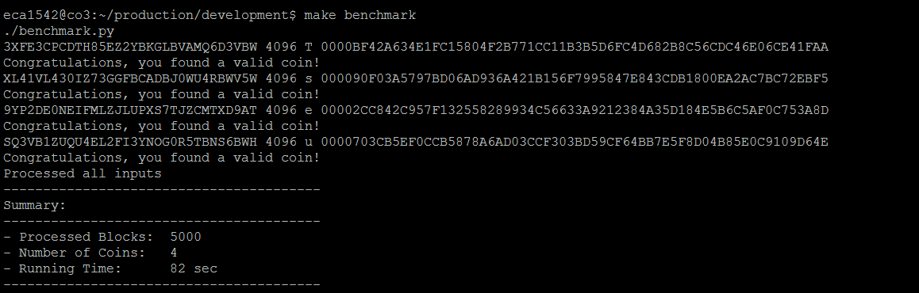

Figure: Benchmark result of implementation with 62 blocks & 32 threads

Benchmark results of C and GPU implementation:

**C implementation: 445 secs**

**GPU implementation: 82 secs**

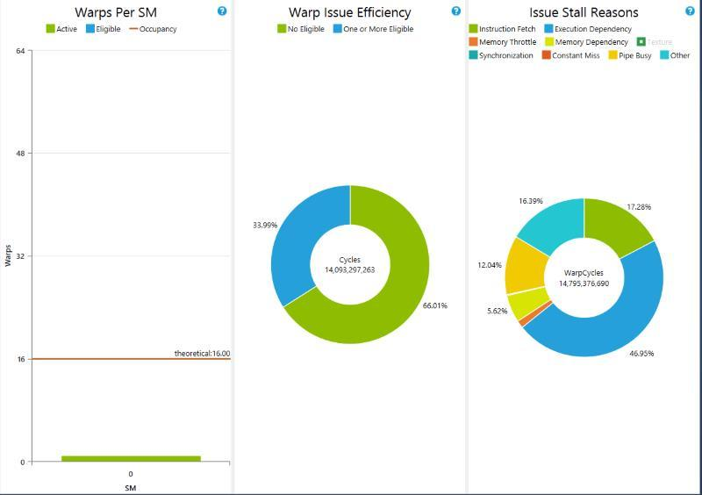

Figure: NSIGHT Visual Profiler – 62 blocks & 32 thread

The above result from NSIGHT visual profiler for 62 blocks & 32 thread implementation shows that instruction fetch is drastically reduced in comparison to the implementation with 1 thread. This implementation is achieved by sharing memory, the reason being the access to shared memory is faster than that of global memory.

# **Conclusion**

However the GPU speeds up the process , the syncthreads function needs to be called before the part that involves sequential programming or the part that can be executed only after all the threads finishes the previous computation. This actually decreased the performance and decreases more when number of threads at the time of kernel is increased. The GPU is therefore efficient at parts of the program where there is much scope for parallelism. The loop unrolling pragma when given at various places did not reduce the time taken by the application. Hence smart utilisation of GPU is required of better optimisation of the application.

**References**:

[1] NVIDIA Programming Guide

<http://docs.nvidia.com/cuda/cuda-c-programming-guide/#axzz3MKfw8Qcr>